Egypt’s
Energy
Balance

Supervised by: Eng. Mahmoud Serag
Prepared By:
Alaa Ragab Hani
Esraa Mohamed Hassan
Hassan Medhat Rashed
Mona Abul Sabour Al Sayed
Moustafa Ahmed Khalil
Nancy Gamal Eldin Azazy
Driving the Future

Energy Balance KPIs Dashboard (1971-2018)
CLS CAI3_DAT2_G4
Group 1

Egypt’s Energy Balance Dashboard (1971-2018)
“Driving the Future”

CLS CAI3_DAT2_G4
“Group 1”

Supervised by: Eng. Mahmoud Serag
Prepared By:
- Alaa Ragab Hani
- Esraa Mohamed Hassan
- Hassan Medhat Rashed
- Mona Abul Sabour Al Sayed
- Moustafa Ahmed Khalil
- Nancy Gamal Eldin Azazy

Index

Table of Contents
Table of Contents 2
List of Acronyms 3
1. Introduction 5
1.1 Project Proposal 5
• Overview 5
• Objectives 5
• Scope 5
1.2 Project Overview 5
• Project Purpose 5
• Milestones 6
• Deliverables 6
• Task Assignment & Roles 6
• Risk Assessment & Mitigation Plan 7
• Timeline (Gantt chart) 8
• Resource Allocation 8
• Key Performance Indicators (KPIs) 8
2. Requirements Gathering 10
2.1 Stakeholder Analysis 10
2.2 User Stories & Use Cases 11
3. Project Analysis & Design 12
3.1 Problem Statement & Objectives 12
3.2 Data Source 12
3.3 Functional Requirements 12
3.4 Data Flow 12
3.5 Database Design & Data Modeling 13
• System Behavior 13
4. Implementation (Source Code & Execution) 14
4.1 Version Control & Collaboration 14
4.2 Deployment & Execution 14
5. Testing & Quality Assurance 16
• Functional Testing 16
• Bug Reports & Resolutions 16
• Automated Testing 16
6. Final Presentation & Reports 17
7. Insights and Recommendations concluded from data strategic analysis of Egypt's Energy System (1971-2018) 18
7.1 Exponential Growth in Energy Demand Creates Sustained Pressure on Resources and Infrastructure. 18
7.2 The Transportation Sector Emerges as the New Primary Driver of Energy Consumption Growth, Overtaking Industry. 18
7.3 Overall Energy System Efficiency Shows a Long-Term Decline. 19
7.4 The Economy Has Not Decoupled Economic Growth from Energy Consumption. 19
7.5 A Strategic Shift in the Energy Mix: From Oil Dominance to Heavy Reliance on Natural Gas 20
7.6 The Contribution of Renewable Energy Has Remained Marginal for Decades 20
7.7 Dominance of Petroleum Products in Final Consumption Reveals the Economy's Main Artery and its Vulnerabilityin 21
7.8 The Success Story of "Electrification and Gasification" Reshaped Demand but Exposed the Efficiency Challenge 21
8. Egypt Energy Balance 2023 Insights 23
8.1 Energy Supply Analysis: The Dominance of Gas 23
8.2 Sectoral Consumption: Transport vs. Industry 23
8.3 Power Systems & Electricity Generation 24
8.4 Industrial Utilization: Energy vs. Feedstock 24
8.5 Energy Intensity Trends (Efficiency) 24
9. Executive Summary 25
10. Project Review 26
10.1 Feedback & Evaluation 26
10.2 Suggested Improvements 26
11. Appendices 27
11.1 Appendix A: Sample Power BI Screenshots 27
11.2 Appendix B: Data Tables Overview 30
11.3 Appendix C: DAX Calculations Summary 35
11.4 Appendix D: User Guide for Egypt Energy Balance Dashboard 42
11.5 Appendix E: DETAILED README 44

List of Acronyms
- API – Application Programming Interface
- BI – Business Intelligence
- CAPMAS – Central Agency for Public Mobilization and Statistics
- DAX – Data Analysis Expressions
- DEPI – Digital Egypt Pioneers Initiative
- ETL – Extract, Transform, Load
- EV – Electric Vehicle
- EVs – Electric Vehicles
- FEC – Final Energy Consumption
- GDP – Gross Domestic Product
- GW – Gigawatt
- GWh – Gigawatt-hour
- HHI – Herfindahl–Hirschman Index
- ICT – Information and Communications Technology
- IEA – International Energy Agency
- ktoe – Kiloton of Oil Equivalent
- KPI – Key Performance Indicator
- KPIs – Key Performance Indicators
- LPG – Liquefied Petroleum Gas
- MWh – Megawatt-hour
- PDF – Portable Document Format
- PPT – PowerPoint Presentation
- RE – Renewable Energy
- T&D – Transmission and Distribution
- TFC – Total Final Consumption
- TES – Total Energy Supply
- TPES – Total Primary Energy Supply
- UI/UX – User Interface / User Experience
- UN – United Nations
- XLS – Excel Spreadsheet

Introduction

Project Proposal

Overview
According to the United Nations Division, an energy balance is "an accounting framework for compiling and synthesizing data on all energy products entering and present in a given country and its national territories during a specific reference period."
Since energy is essential for economic development, energy balance is an essential tool for analysing the energy sectors and status of the country regarding its national and international commitments, also its strategic and economic targets to be aligned with the sustainability goals, fulfil its energy Security, diversification in sources of energy supplies and sources of the country, and ensure energy efficiency.

Objectives
This project aims to perform an in-depth data analysis of the Egyptian energy balance (1971-2018) by combining robust data analysis techniques with sector-specific insights providing a solid basis for evaluating the performance of the energy sector.

Scope
- Assess Egypt status in relation to national and international commitments.
- Support the achievement of strategic and economic targets.
- Ensure alignment with sustainability goals.
- Contribute to strengthening energy security of Egypt
- Encourage diversification of energy supply sources.
- Promote energy efficiency and optimal resource utilization.
- Generate actionable insights to guide decision makers.

Project Overview

Project Purpose
To create a data-driven platform that visualizes Egypt’s energy performance, tracks sustainability indicators, and provides insights to guide strategic decisions.

Milestones
  - Data Collection & Cleaning
  - Etl Pipeline Development
  - Relationship Building & Modeling
  - DAX Measures Calculation
  - Data Visualization & Dashboard Design.

Deliverables
  - Comprehensive project documentation.
  - Detailed performance KPIs.
  - Analytical reports on consumption patterns, renewable integration, and energy efficiency trends.
  - Dynamic, interactive Power BI dashboard for data visualization of narrating Egypt's Energy Balance, highlighting KPIs that support policy-making and long-term energy planning.
  - Video navigation the Power BI dashboard.

Task Assignment & Roles
Role | Team Member | Responsibilities
Team Leader | Alaa | Project delivery and GitHub submission.
Project Manager | Nancy | Project coordination, task distribution, communication with stakeholders, progress tracking.
Data Engineer (ETL) | Esraa | Data extraction, transformation, and loading; ensuring data consistency and validity.
Data Cleaning Specialist | Mona - Nancy | Handling dataset inconsistencies, preparing cleaned data for analysis.
KPIs Determiner | Nancy | Data relationship building and determining KPIs
Measures & calculation | Mostafa | DAX measures, KPI implementation.
Dashboard & Visualization Developer | Mostafa - Esraa - Nancy - Mona | Building Power BI dashboards.
Documentation Lead | Hassan - Nancy - Alaa | Preparing project documentation.
Presentation Designer | Alaa | Designing final slides and visualization for stakeholders.

Risk Assessment & Mitigation Plan
No. | Risk/ Challenge | Mitigation Plan
1 | All the team members except Nancy have different background not related to the energy sectors. | Intensive meetings and awarness sessions were made in the begening of the project for all the team members about the energy analysis.
2 | Some irrational data due to poor data entry in some years especially pre-1980 & energy items. | Data correction through insightful analysis of general data.
3 | Energy Data Confidentiality issue | - Data obtained from open sources online  IEA – International Energy Agency  and world bank for the period 1971-2018.  - 2023 Energy data from Central Agency for Public Mobilization and Statistics (CAPMAS)  - 2019-2021 Energy data weren’t used and not recommended due to COVID-19 pandemic.
4 | The format and alignment of data wrent suitable for analysis | Creative solutions by using knowledge gained through DEPI inetiative in ETL and DAX measures for dealing with this hard data.

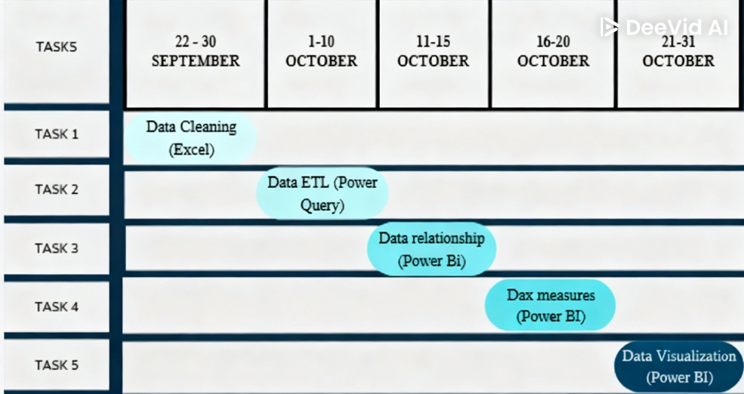
Timeline (Gantt chart)

Resource Allocation
  - ~10–15% of the total project timeline to ensure the system's sustainability and regulatory compliance.
  - 40% of work was assigned primarily to the Power BI Analyst for technical mapping and DAX measures to validate business logic, such as defining specific KPIs for energy Efficiency and renewable energy targets.
  - 30% of work was for visualizing the energy data in interacyive astrategic view in addition to adding a sanky diagram an addittional visualisation tool for the most recent energy balance data 2023.
  - Finally, 15% of work was for documentation, presenting the project in different platforms such as GitHub.

Key Performance Indicators (KPIs)
KPI | Description
Response Time | Measures how quickly the dashboard loads data and visualizations for users.
User Adoption Rate | Tracks the percentage of target users actively engaging with and utilizing the dashboard over time.
Import Dependency Ratio | Calculates the proportion of energy consumed that is imported. It can be expressed as a percentage of the total energy consumption.
Energy Mix Diversity Index | Measures how varied a country's energy sources are in its energy mix. Index, typically between 0 and 1.
Electricity Generation Diversity | Measures the variety of energy sources in the electricity generation mix. It can be measured using the Herfindahl-Hirschman Index (HHI), which quantifies the concentration of generation sources.
Electricity in Residential | Measures electricity consumed by households.
Energy Intensity | Measures the energy efficiency of the economy by calculating the ratio of TPES to GDP.
RE Share in Electricity Generation | Calculates the percentage of renewable energy in the total energy generation.
RE Electricity Generation | Measures the production of electricity using renewable energy sources.
Sector Analysis | Measures energy consumption patterns across different sectors.
TPES (Total Primary Energy Supply) | Measure of the total energy available for consumption.
Transformation consumption | Measures the energy lost or consumed during the process of converting energy from one form to another, like converting crude oil to fuels or coal to electricity.
TFC (Total Final Consumption) | Measures the energy consumed by end-users like households, industry, transport, etc., after transformation and distribution losses.
Electricity Transmission and Distribution Losses | Refers to energy losses that occur when electricity is transmitted and distributed from power plants to end-users.
Electrification (% of electricity use in FEC) | Shows the share of electricity in total final energy consumption.

Requirements Gathering

Stakeholder Analysis
- Stakeholders
Egyptian presideny, The Egyptian Cabinet (Presidency of the Council of Ministers), ministry of electricity and renewable energy, Ministry of Petroleum and mineral resources, Ministry of Communications and Information Technology
- Needs
  - Renewable Energy Expansion: Identify opportunities for solar, wind, and hydroelectric power growth to increase renewable energy capacity.
  - Energy Efficiency: Understand energy consumption patterns to reduce waste, optimize energy distribution, and promote energy-efficient technologies.
  - Fuel Subsidy Reform: Inform pricing strategies and mitigate the impact on vulnerable populations.
  - Investment Attraction: Showcase Egypt's energy potential to attract investments in renewable energy projects.
  - Sustainable Development: Achieve sustainable development goals, including reducing greenhouse gas emissions and promoting economic growth while protecting the environment.
  - Energy Policy and Planning: Inform energy policy and planning to ensure a sustainable energy mix.
  - Resource Allocation: Optimize energy resource allocation to maximize efficiency and productivity.
  - Energy Security and Sustainability: Enhance energy security and sustainability to ensure a reliable energy supply.
  - Economic Growth: Drive economic growth through renewable energy investments.
  - Public Health and Environmental Protection: Improve public health and environmental protection by reducing pollution and promoting clean energy

User Stories & Use Cases
- Energy Production and Consumption Analysis
  - Monitor Egypt's energy production and consumption patterns, identifying areas for improvement and opportunities for renewable energy growth.
  - Analyze the dashboard to inform policy decisions, such as optimizing energy subsidies and promoting energy efficiency.
- Renewable Energy Expansion
  - Track progress towards Egypt's renewable energy targets, identifying areas for investment and development.
  - Evaluate the effectiveness of initiatives like the African Global Hydrogen Summit, aimed at maximizing the green industrial revolution in Africa.
- Energy Security and Sustainability
  - Assess Egypt's energy security, identifying potential risks and opportunities for diversification.
  - Inform decisions on energy infrastructure development, ensuring a reliable and sustainable energy supply.
- International Cooperation and Investment
  - Showcase Egypt's energy potential, attracting investments in renewable energy projects and promoting international cooperation.
  - Help Egypt's leaders evaluate the impact of partnerships, such as the agreement with France to enhance energy sustainability and provide clean energy solutions.

Project Analysis & Design

Problem Statement & Objectives
No Visualization tool or dashboard has been done before for Egypt Energy Balance data analysis.

Data Source
Official datasets from the United Nations, World Bank, and Egypt’s Ministry of Electricity and Energy.

Functional Requirements
- Data Visualization
  - Interactive charts & graphs to display energy production & consumption patterns
  - Maps to show energy infrastructure and resource distribution
- Energy Production Analysis
  - Tracking of energy production from various sources (renewable, fossil fuels, etc.)
- Energy Consumption Analysis
  - Breakdown of energy consumption by sector (industrial, residential, etc.)
  - Identification of peak demand periods and trends
- Energy Efficiency Analysis
  - Assessment of energy efficiency measures
  - Identification of areas for energy efficiency improvement
- Reporting and Export
  - Generation of reports and summaries for stakeholders
  - Export of data and reports in various formats (PDF, XLS, etc.)

Data Flow
- Gather Data: Collect sheets of primary energy items, transformation, and consumption by sector from 1971 to 2018 using Power Query.
- Normalize Tables: Normalize the fact table into dimension tables such as sectors and energy product types.
- Clean and Transform: Use Power Query to clean, transform, and standardize the data.
- Add KPIs: Create measures using DAX to define key performance indicators (KPIs).
- Visualize Data:
- Build 3 main report pages:
  - Total Primary Energy Supply
  - Total Final Energy Consumption
  - Sector Analysis
- Two Supplementary pages for clarification:
  - Sankey Diagram
  - Overview (containing the most important features from all pages)
- Bookmarks: Implement bookmarks for navigation menus on the Home page and additional info on the Sankey Diagram page.
- Tooltips: Use tooltips to present more information on the Sankey Diagram and on the Overview page to connect related data.
- Drill through: Enable drill through from the Total Final Energy Consumption page to the Sector Analysis page for detailed sector insights.
- Dashboard Design: Design the dashboard with a theme inspired by energy, ensuring consistency with the presentation and documentation. Making it easy to navigate and more insightful.

Database Design & Data Modeling
A Fact table is the energy sources and other tables are dimension tables and measures.

System Behavior
- Dashboard consists of:
  - Home page, overview,
  - Sankey diagram for Egypt energy balance and flow of energy year 2023,
  - Primary energy Supply Analysis page,
  - Final Energy Consumption analysis page and
  - Sector Analysis page.
- Navigation is done through clickable buttons in each page.

Implementation (Source Code & Execution)

Version Control & Collaboration
- Version Control Repository
The project is hosted on GitHub using a private/public repository to store:
  - Power BI files (.pbix)
  - DAX measures documentation
  - Power Query M-scripts
  - Data dictionary
  - Project documentation (PDF/DOCX)
The repository serves as the central location for collaboration, versioning, and project tracking.
- Branching Strategy
A lightweight branching strategy is used, suitable for analytics projects:
- Main branch: Contains the final, approved Power BI dashboard and documentation.
- Subsequent branch: Used for active development, adding visuals, DAX measures, or data transformations.
Each feature branch is merged only after validation.
- Commit History & Documentation
Meaningful commit messages and detailed pull request descriptions.

Deployment & Execution
- README File
- Requirements
  - Microsoft Power BI Desktop (latest version)
  - Windows 10/11
  - 8GB RAM minimum (16GB recommended)
- Installation & Opening
  - Download or clone the GitHub repository.
  - Open Egypt Energy Balance 1971–2018.pbix using Power BI Desktop.
- Configuration
  - Refresh all Power Query connections.
  - Validate DAX measures load correctly.
  - Ensure slicers and bookmarks respond properly.
- Using the Dashboard
  - Navigate using the menu on the Home page.
  - Use sliders, filters, tooltips, and drill-throughs.
  - Export visuals or data using the (⋯) button.
- Optional Deployment
If published to Power BI Service:
  - Stakeholders can view the dashboard using an access-controlled link.
- User Guide Summary
- Getting Started
- Open Egypt Energy Balance 1971–2018.pbix in Power BI Desktop.
- You will land on the Home page, which explains the dashboard purpose.
- Use the top-right menu to navigate across pages:
  - Sankey Diagram
  - Overview
  - Total Primary Energy Supply
  - Total Final Energy Consumption
  - Sectors Analysis
- Common Interactions
- Year Slider: select one year or a range.
- Hover Tooltips: view exact values for any point.
- Legend Toggle: click legend items to show/hide categories.
- Export Options (⋯): export visuals or data.
- Back Arrow: return to Home from any page.

- Page Summaries
- Sankey Diagram – Shows energy flow from supply → transformation → final use.
- Overview – High-level trends and sector shares.
- TPES Page – Detailed supply analysis by product and type.
- TFC Page – Detailed demand analysis and efficiency metrics.
- Sectors Analysis – Deep comparison of Industry, Residential, Transport, and Others.
- Tips
- Use Focus Mode for large charts.
- Click Info (i) icons for quick explanations.
- Ensure you click Apply after adjusting filters (if required).

Testing & Quality Assurance
- Test Cases & Test Plan
A structured test plan was developed to validate the dashboard’s performance and correctness.
Key test cases included:
- Verification of DAX measures (TPES, TFC, TFC/TPES %, sector shares).
- Ensuring accuracy of Power Query transformations and data cleaning steps.
- Navigation checks for all buttons, bookmarks, and drill-through actions.
- Validation of slicers (Year slider, product type filters) across all pages.
- Consistency checks between visual values and underlying dataset.

Functional Testing
Manual testing confirmed:
- Charts update dynamically with selected years or filters.
- Tooltips show correct values across all visuals.
- Sankey diagram flows match the underlying dataset.
- KPI cards correctly reflect calculations across all years.

Bug Reports & Resolutions
Examples include:
- Incorrect values in early-year data → fixed through Power Query cleaning adjustments.
- Navigation misalignment on certain pages → corrected bookmark paths.
- TFC/TPES % calculation mismatch → corrected DAX measure logic.

Automated Testing
While no automated testing scripts were used (as is typical for Power BI projects), the following repeatable validations were applied:
- Automated refresh check (Power BI Desktop refresh and Power BI Service refresh).
- Consistency check using Power BI Desktop’s "View Performance Analyzer" to validate responsiveness.
- Power Query applied steps validation—checked for failure/incorrect data types during refresh.

Final Presentation & Reports
- User Manual
A full user guide is provided to ensure smooth adoption by analysts, policymakers, and stakeholders.
It includes:
- How to open the Power BI file
- Navigation structure (Home → Overview → Sankey → TPES → TFC → Sectors)
- Explanation of KPIs
- How to use filters, drill-through, tooltips, and slicers
- Guidance on exporting visuals or data
- Tips for exploring the dashboard effectively
- Technical Documentation
Detailed documentation of:
- Data ingestion and cleaning workflows (Power Query ETL)
- DAX measures and KPI definitions
- Data model schema (fact & dimension tables)
- System architecture of the dashboard (Raw Data → Power Query ETL → Data Model → DAX Measures → Visual Layers → Final Dashboard)
- Project Presentation (PPT/PDF)
A professional presentation summarizing:
- Project goals
- Data sources
- Modeling and ETL process
- Key insights from 1971–2018
- Policy and strategic recommendations
- 2023 Energy Balance findings
- Video Demonstration
A short, recorded walkthrough presenting:
- How to use the dashboard
- How KPIs change with filters
- Navigation and drill-through functions

Insights and Recommendations concluded from data strategic analysis of Egypt's Energy System (1971-2018)

Exponential Growth in Energy Demand Creates Sustained Pressure on Resources and Infrastructure.
- Observation: The (TPES and TFC by Year) and (Electricity Generated... by Year) charts show continuous and steep growth in Total Primary Energy Supply, Total Final Consumption, and electricity generation over the past five decades.
- Context: This massive growth is directly correlated with Egypt's rapid population growth, urbanization, and industrial economic development during this period.
- Implication: This relentless growth puts immense pressure on the energy infrastructure (power plants, grids) and requires massive, continuous investment just to keep pace with demand, posing a challenge to national energy security.
- Recommendation: The national energy strategy must evolve from merely "meeting demand" to actively "managing demand." It is critical to implement robust energy efficiency and conservation policies across all sectors to moderate the demand growth rate and make it more sustainable.

The Transportation Sector Emerges as the New Primary Driver of Energy Consumption Growth, Overtaking Industry.
- Observation: The chart (Industry Share%, Residential share% and Transportation share% by Year) reveals a major structural shift in consumption patterns. While the industrial sector's share was historically dominant, the transportation sector's share has been steadily rising since the 1990s, eventually surpassing industry to become the largest consuming sector.
- Context: This shift reflects a significant increase in private vehicle ownership, a reliance on road transport for freight, and the lack of sufficient and efficient mass transit alternatives nationwide.
- Implication: The transportation sector is now the single greatest challenge to achieving energy sustainability and reducing emissions, given its near-total dependence on petroleum products.
- Recommendation: An urgent and targeted strategy for the transportation sector is required, focusing on developing public transport networks (e.g., metro, electric trains), incentivizing the shift to electric vehicles (EVs), and improving vehicle fuel efficiency standards.

Overall Energy System Efficiency Shows a Long-Term Decline.
- Observation: The (TFC/TPES by Year) chart, which shows the ratio of final energy consumed to the primary energy supplied, displays a general downward trend over the decades. The ratio was higher in the 1970s and 80s and has been declining since, meaning the gap between the energy produced and the energy that reaches the end-user is widening.
- Context: The primary driver for this decline is the increasing share of electricity in the final consumption mix. The process of converting fossil fuels to electricity in thermal power plants involves significant inherent energy losses. As electricity's share grows, the system's overall efficiency drops.
- Implication: Egypt is wasting a growing percentage of its primary energy resources in conversion and transmission processes. This represents a major economic and environmental loss.
- Recommendation: A concentrated effort must be made to boost the efficiency of the power generation sector (using modern technologies) and reduce losses in the distribution grid (the `Rate of distribution loss of electricity` chart shows that losses are high and volatile).

The Economy Has Not Decoupled Economic Growth from Energy Consumption.
- Observation: The (Sum of TFC/GDP %) chart, which measures the energy intensity of the economy, does not show a clear and sustained long-term decline. After some fluctuations, the curve appears to have flattened or is declining very slowly in recent years.
- Context: This means that every unit of GDP requires an amount of energy that has not significantly decreased over time. In contrast, advanced economies typically show a clear drop in this indicator as they shift towards technology and service-based industries.
- Implication: This tight coupling makes future economic growth very energy-intensive and costly, limiting the ability to achieve environmentally sustainable growth.
- Recommendation: National policies must be implemented to actively "decouple" economic growth from energy consumption by promoting knowledge-based and service industries and enforcing strict energy efficiency codes for new buildings and factories.

A Strategic Shift in the Energy Mix: From Oil Dominance to Heavy Reliance on Natural Gas
- Observation: The TPES by Year and Energy Product chart clearly illustrates a fundamental transformation in the primary energy mix. While crude oil was the dominant source until the late 1990s, natural gas began to grow exponentially, becoming Egypt's largest single source of energy since the early 2000s.
- Context: This was not a random shift, but the result of a strategic state policy following major discoveries of natural gas fields in the Mediterranean Sea. This gas was directed to fuel new power plants and expand the distribution network to homes and factories.
- Implication: While this transition successfully reduced reliance on imported oil and enhanced energy security, it created a new form of dependency on a single fossil fuel (natural gas), leaving the economy exposed to long-term production and price risks.
- Recommendation: The next strategic energy transition must be from reliance on natural gas to true diversification towards renewable sources. Egypt should not wait for gas resources to deplete before initiating this critical shift.

The Contribution of Renewable Energy Has Remained Marginal for Decades
- Observation: Despite the overall massive growth in energy supply, the TPES by Year and Energy Product Type donut and area charts show that the contribution of renewables has remained consistently low, accounting for only about 5% of the Total Primary Energy Supply.
- Context: Historically, political and investment focus was centered on exploiting discovered fossil fuel resources (first oil, then gas). Large-scale renewable energy projects only began to gain significant momentum in the very last few years of the period covered by this analysis.
- Implication: This represents a massive, missed opportunity over several decades to leverage Egypt's rich natural resources (sun and wind) to achieve environmental and economic sustainability, and to create jobs in the green economy.
- Recommendation: More ambitious and binding renewable energy targets must be set, supported by strong investment incentives and streamlined regulations to accelerate project implementation and grid integration.

Dominance of Petroleum Products in Final Consumption Reveals the Economy's Main Artery and its Vulnerabilityin
- Observation: The TFC by Energy Product donut chart shows that petroleum products (gasoline, diesel, etc.) account for the largest share of final energy consumption, at over 56%.
- Context: This dominance is directly tied to the transportation sector's leading role in energy consumption (cars, trucks, buses), in addition to other uses in industry and agriculture.
- Implication: This heavy dependence on petroleum products makes the cost of transport and goods in the Egyptian economy extremely sensitive to global oil price fluctuations. It is also the primary source of urban air pollution.
- Recommendation: More than anything else, this statistic underscores the urgent need to diversify energy sources within the transportation sector. Investing in transport electrification (EVs) and expanding electric mass transit networks is not just an environmental luxury; it is a strategic economic imperative.

The Success Story of "Electrification and Gasification" Reshaped Demand but Exposed the Efficiency Challenge
- Observation: The TFC by Year and Energy Product area chart displays massive growth in the final consumption of electricity and natural gas since the 1980s. Together, they now represent a very significant share of final consumption (approx. 18.4% each).
- Context: This reflects successful government policies to expand the national electricity grid and to connect homes and factories to the natural gas network as an alternative to LPG cylinders and heavy fuel oil.
- Implication: While this has improved the quality of life and supported industrial growth, it is also the direct cause of the declining overall system efficiency (the TFC/TPES ratio). We are now consuming more "secondary energy" (electricity), which involves significant primary energy losses during generation.
- Recommendation: Since the shift towards electricity and gas is irreversible and beneficial for the end-user, the focus must now shift to making that electricity and gas supply more sustainable. This means generating electricity from renewable sources and boosting the efficiency of power plants.

Egypt Energy Balance 2023 Insights
The 2022/2023 energy balance reveals an economy heavily anchored in Natural Gas (53%) and Petroleum (41%). While energy intensity is improving (indicating better efficiency per unit of GDP), the power sector remains the primary driver of gas demand, with significant conversion losses inherent to thermal generation.
- Renewable Energy Share: Fossil fuels still dominate Egypt's electricity generation, at 88% in 2023. Hydropower contributed 7%, and wind and solar accounted for 5%. The total installed capacity of renewable energy reached 7.7 GW across all types (wind, solar, and hydro).
- Consumption Trends: Primary energy consumption in Egypt showed a slight decline of 1% in 2023, following a 6% decline in 2022.

Energy Supply Analysis: The Dominance of Gas
Egypt's total primary energy supply (TES) for the fiscal year was 92,057 thousand tons of oil equivalent (ktoe). The mix highlights a rigid dependence on fossil fuels:
- Natural Gas: 53% of total supply.
- Crude Oil & Petroleum Products: 41% of total supply.
- Other Sources: Coal, Coke, and Renewables (Hydro, Wind, Solar) combined make up only roughly 6%.
The "Energy Balance Sankey 2023" confirms that natural gas is the backbone of the system, feeding both the massive power generation sector and industrial feedstocks.

Sectoral Consumption: Transport vs. Industry
Total Final Energy Consumption (FEC) stood at 58,646 ktoe. The consumption behavior varies starkly by sector:
Sector | Share of Consumption | Primary Energy Source
Transport | 38% (Highest) | Almost exclusively Petroleum Products.
Industry | 27% | Mixed (Gas, Electricity, Petroleum).
Residential | 21% | Heavily reliant on Electricity and Natural Gas.
Others | 14% | Includes Trade, Services, Agriculture.

Power Systems & Electricity Generation
For a power systems engineer, the conversion and loss data in this report is critical. The electricity sector is the primary "sink" for natural gas supply.
- Generation Mix: 59% of Egypt's total natural gas supply is consumed solely for electric power generation.
- Grid Performance:
  - Transmission & Distribution (T&D) Losses: 3,521 ktoe.
  - Comparing T&D losses (3,521) to final consumption (14,281), the grid losses represent a significant percentage of delivered energy, highlighting an area for potential infrastructure optimization.

Industrial Utilization: Energy vs. Feedstock
The industrial sector consumed 13,269 ktoe of Natural Gas. However, not all of this is burned for power:
- Fertilizers: This specific sub-sector consumed 37% of industrial natural gas.

Energy Intensity Trends (Efficiency)
A positive trend is observed in the "Energy Intensity" indicators, which measure energy used per unit of GDP.
- Total Supply Intensity: Dropped from 14 (2015/16) to 11 (2022/23).
- Final Consumption Intensity: Dropped from 9 (2015/16) to 7 (2022/23).
Insight: Egypt is generating more economic value (GDP) for every unit of energy consumed, indicating a gradual decoupling of economic growth from energy consumption.

Executive Summary

The Egypt Energy Balance Project (1971–2018) provided a data-driven overview of national energy dynamics, supported the identification of key inefficiencies, enabled insights for sustainability and policy improvements, laid the foundation for advanced forecasting models and real-time dashboards supporting Egypt Vision 2030.

The dashboard tells a clear story: Egypt faces a dual challenge of massive, unabated growth in energy demand and a long-term decline in its overall energy system efficiency. The transportation sector has emerged as the new key driver of this consumption. To ensure a secure and sustainable energy future, the strategy must pivot from focusing solely on increasing supply to a more balanced approach that includes aggressive demand-side management, radical efficiency improvements, and a structural transformation of the transportation sector

Project Review

Feedback & Evaluation
Component | Weight | Criteria & Observations
Data Preparation & Modeling (ETL) | 25% | Evaluation of Power Query transformations, data cleaning, and the efficiency of the data model (Star Schema). Usage of DAX measures for complex calculations (e.g., YoY growth in renewable capacity).
Visualization & UI/UX | 25% | Clarity of charts, effective use of space, color consistency, and navigation features. Does the dashboard allow for intuitive drill-down into specific Governorates or Energy Types?
Analytical Depth & Insights | 30% | Ability to derive meaningful conclusions from the Egypt Energy data. Does the analysis identify trends in consumption vs. production, or grid efficiency issues?
Documentation & Presentation | 20% | Quality of the written report, resource allocation planning, and the verbal defense of the project. Clarity of the Data Dictionary.
TOTAL | 100%

Suggested Improvements
Environmental measures such as Carbon emissions index can be added

Appendices

Appendix A: Sample Power BI Screenshots
Dashboard Home Page
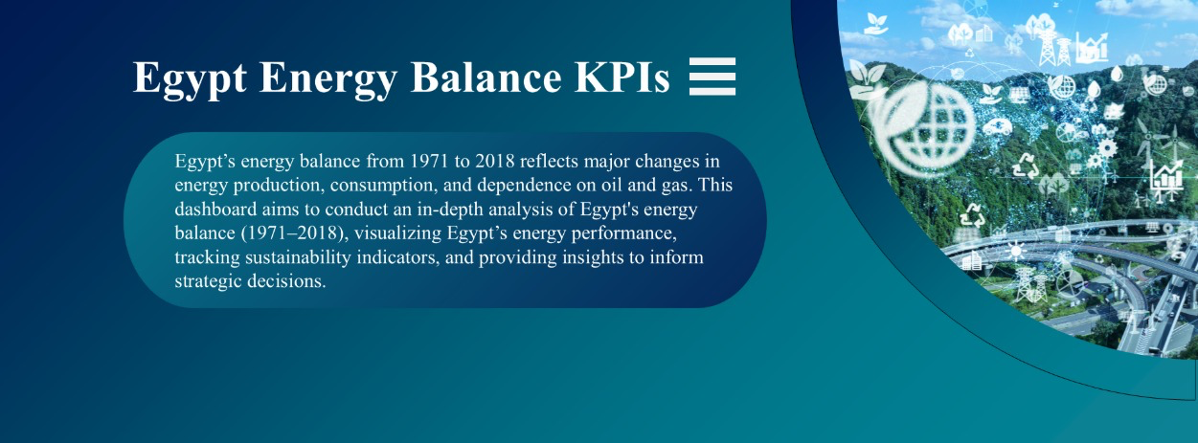

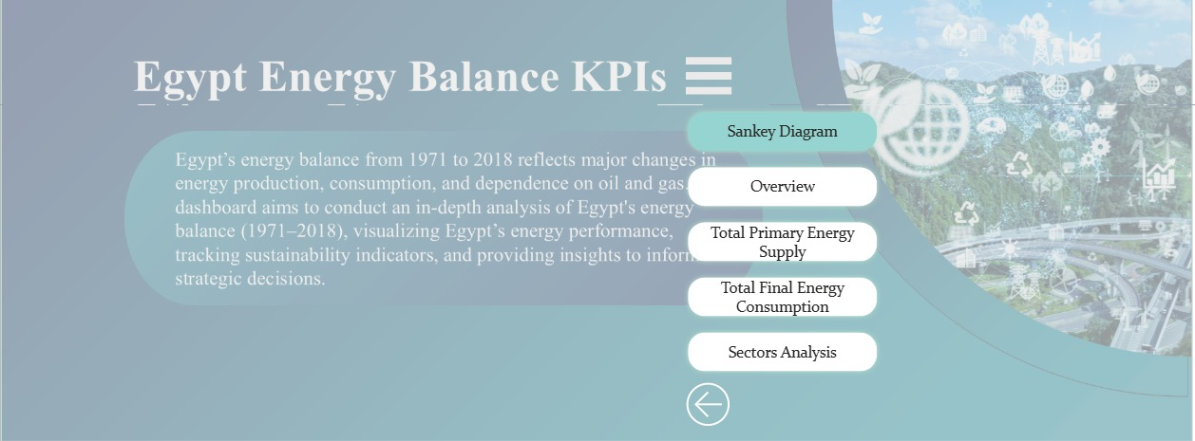
Analysis Overview
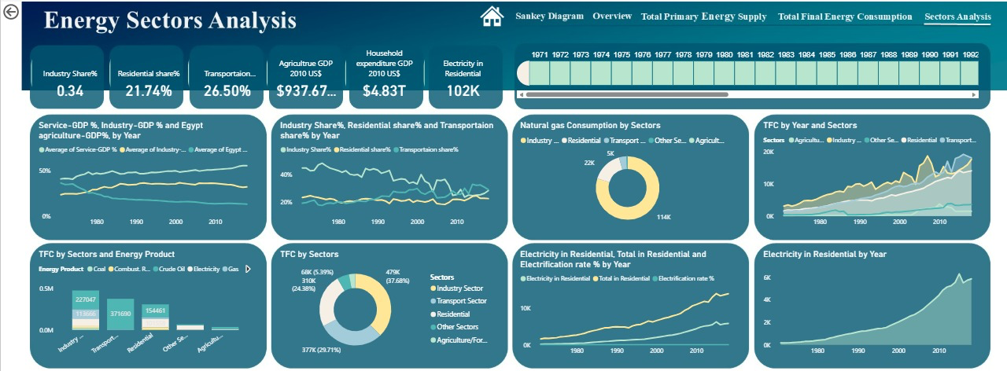
Sankey Diagram
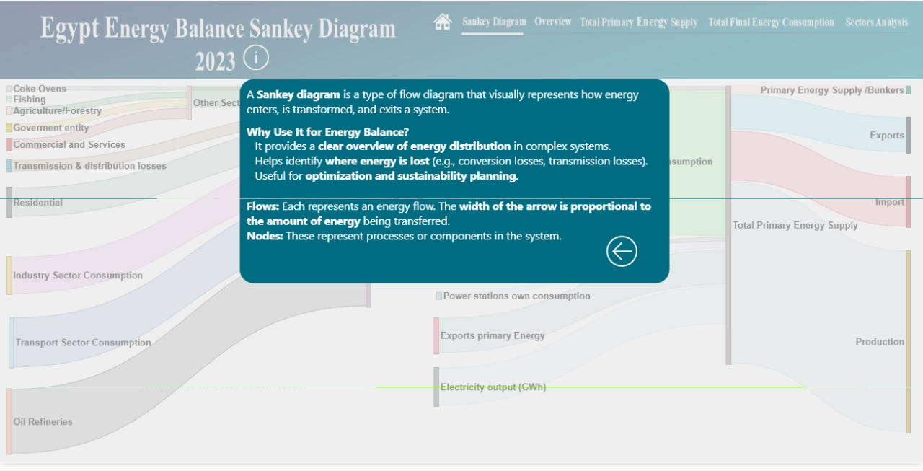

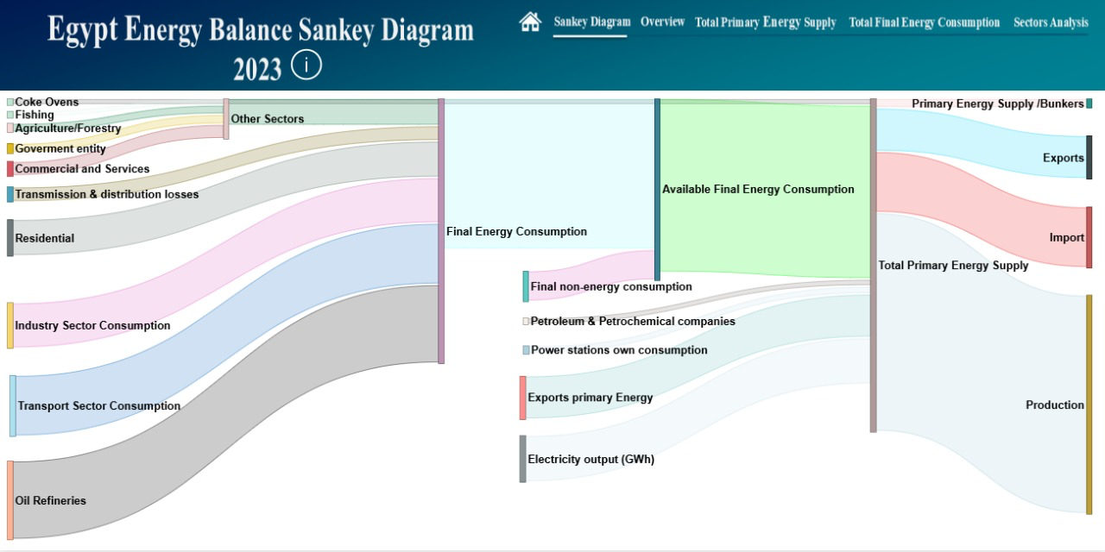

TPES
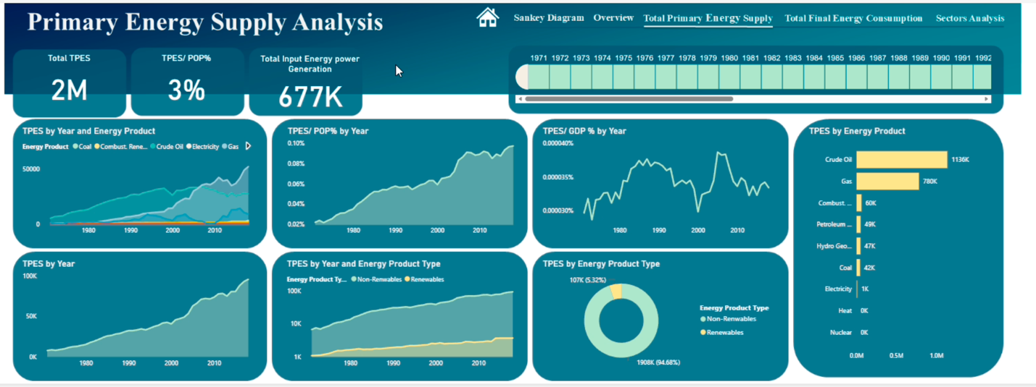

TFC
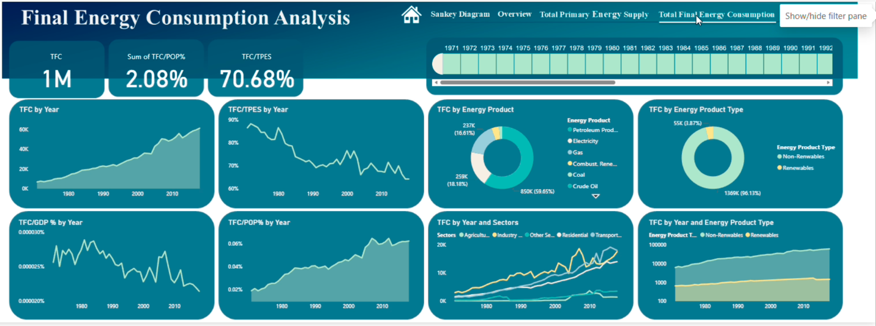
Sector Analysis
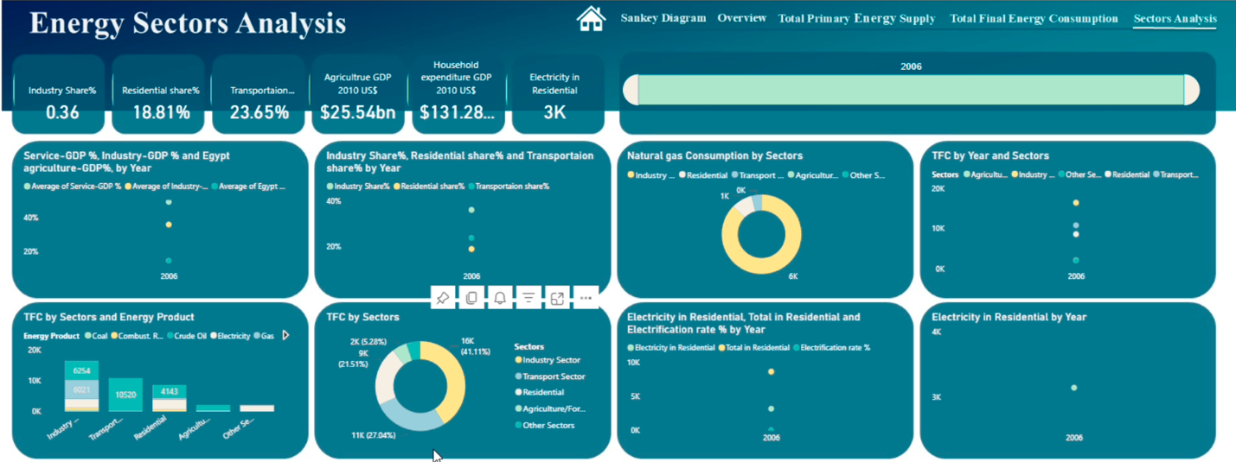

Appendix B: Data Tables Overview
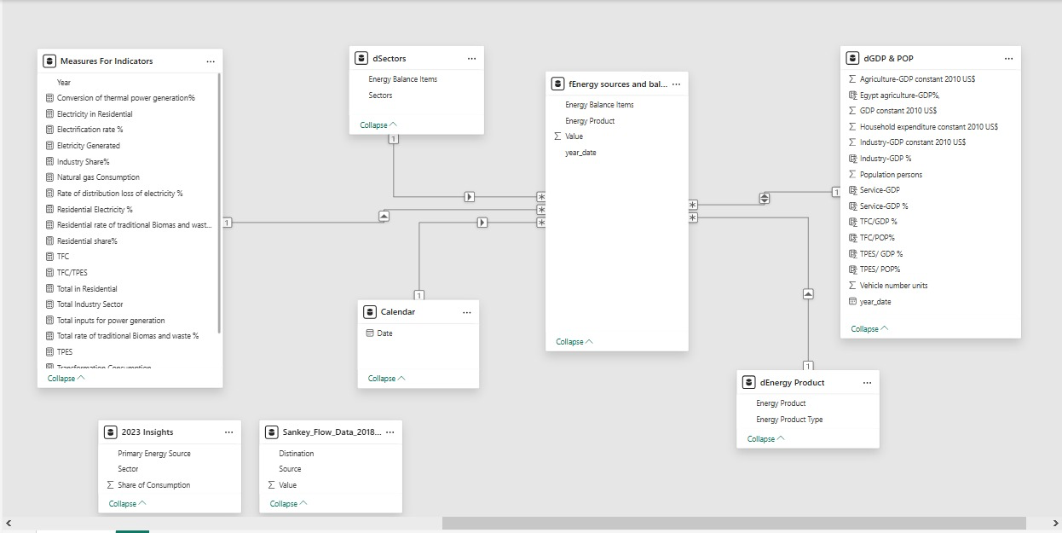
Relationship Diagram

Data Processing
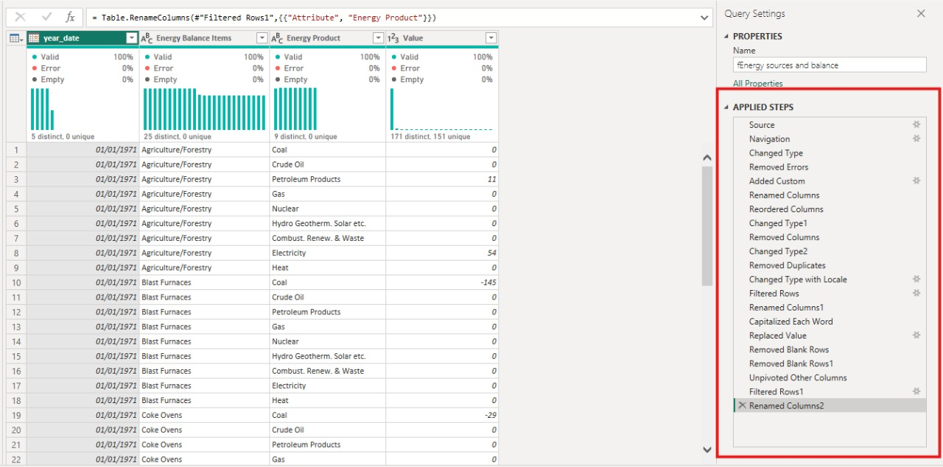

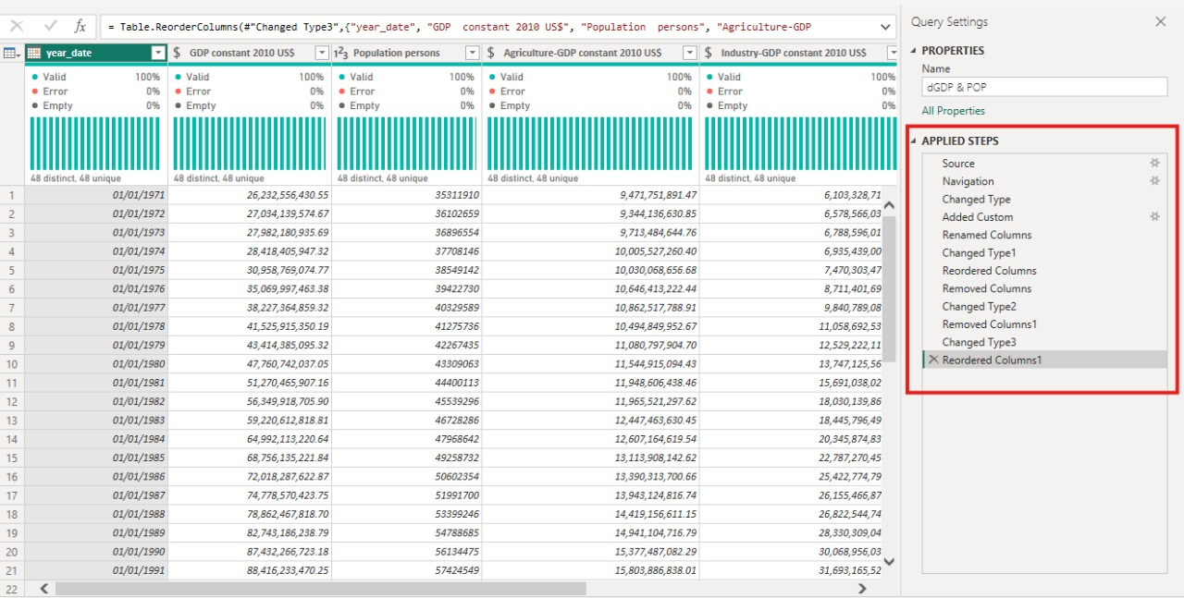


Query Tables


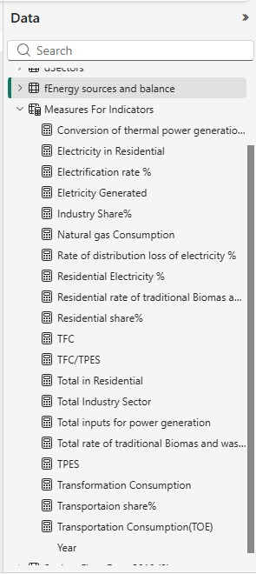
Measures

Data Transformation
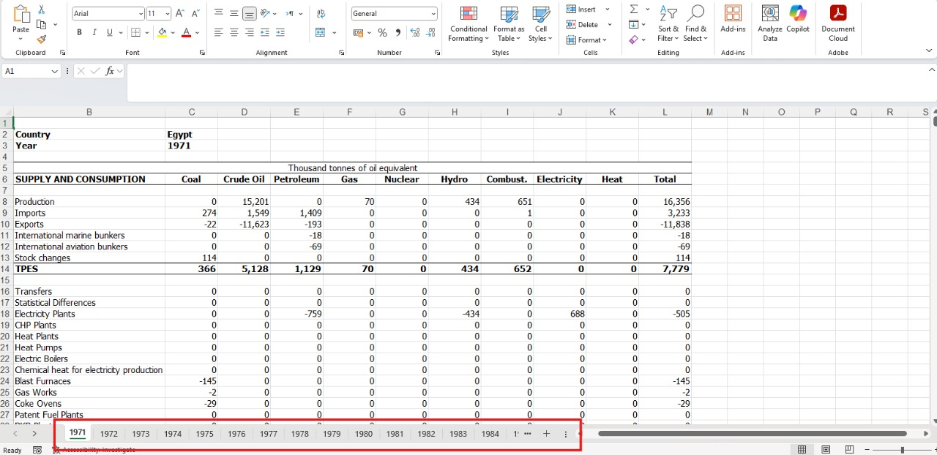
Data collected Sheets from 1971 to 2018

DAX Measure
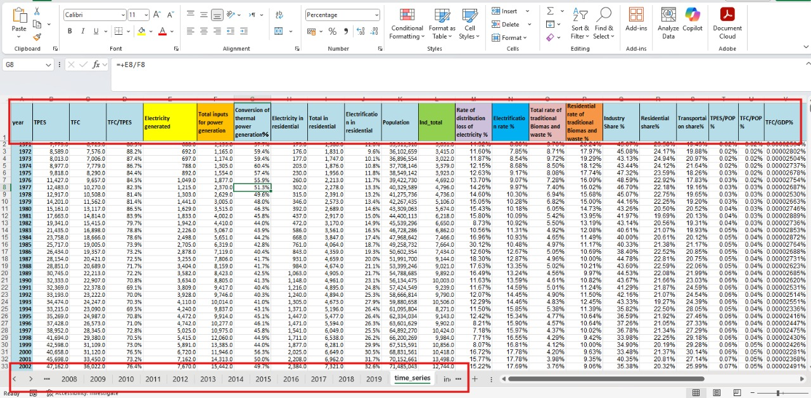

KPIs to Interactive Visualizations
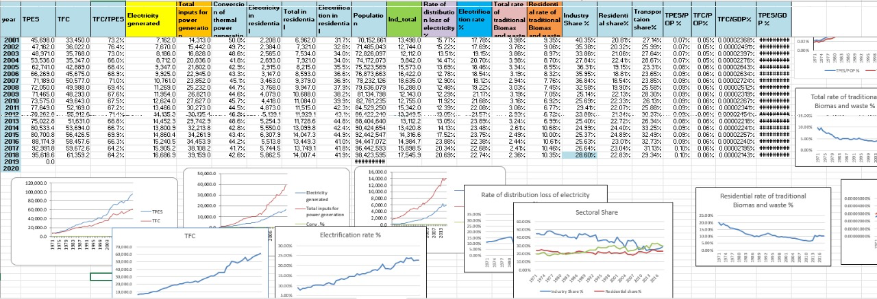

Appendix C: DAX Calculations Summary
- Conversion of thermal power generation (%)
- DAX Formula:
Conversion of thermal power generation％ =
ABS (DIVIDE ([Electricity Generated], [Total inputs for power generation]))
- Description:
Conversion of thermal power generation (%)
This measure calculates the efficiency of thermal power plants in converting fuel or energy inputs into electricity. It is computed as the absolute value of the ratio between the total electricity generated and the total energy inputs used for power generation.
- Formula:
Conversion Rate (%)=∣Electricity GeneratedTotal Inputs for Power Generation Conversion Rate (%)=​Total Inputs for Power GenerationElectricity Generated​​
Where:
- Electricity Generated: Total electricity output produced by the power plants.
- Total inputs for power generation: Sum of all energy sources (inputs) consumed for electricity production.
Note: The ABS function ensures the value is always positive.

- Electricity in Residential
- DAX Formula:
Electricity in Residential = CALCULATE( SUM('fEnergy sources and balance'[Value]),
'fEnergy sources and balance'[Energy Balance Items] = "Residential",
'fEnergy sources and balance'[Energy Product] = "Electricity")
- Description :
Electricity in Residential
This measure represents the total amount of electricity consumed by the residential sector. It is calculated by summing values from the energy balance table where the energy balance item is 'Residential' and the energy product is 'Electricity'.
- Formula (DAX):
Electricity in Residential =
Electrification rate % = ABS (DIVIDE (CALCULATE (SUM ('fEnergy sources and balance'[Value]),'fEnergy sources and balance'[Energy Product] ="Electricity”, fEnergy sources and balance'[Energy Balance Items]
IN {“Non-specified (industry)",
"Rail",
"Residential",
"Commercial and Public Services",
"Agriculture/Forestry"}),
[TFC]))
- 'Value': The quantity of energy consumed (e.g., MWh, GWh).
- 'Energy Balance Items': Breakdown by sector (filtered for 'Residential').
- 'Energy Product': Type of energy (filtered for 'Electricity').

- Electrification rate %
Electrification rate % = ABS (DIVIDE(CALCULATE(SUM('fEnergy sources and balance'[Value]),'fEnergy sources and balance'[Energy Product] ="Electricity”, fEnergy sources and balance'[Energy Balance Items]
IN { "Non-specified (industry)",
"Rail",
"Residential",
"Commercial and Public Services",
"Agriculture/Forestry"}),
[TFC]))
- Description:
This measure calculates the share of electricity in total final energy consumption for key sectors. It sums up electricity consumption for the selected sectors and divides it by the Total Final Consumption (TFC).

- Electricity Generated
Electricity Generated = CALCULATE(
SUM('fEnergy sources and balance'[Value]),
'fEnergy sources and balance'[Energy Product] = "Electricity”, fEnergy sources and balance'[Energy Balance Items] = "Transformation Electricity Output")
- Description:
Total electricity produced and sent out from power generation facilities.

- Industry Share%
Industry Share% = DIVIDE ([Total Industry Sector], [TFC])
- Description:
The ratio of the industry's total energy consumption to total final consumption (TFC), representing the industry's share in overall energy use.

- Natural gas Consumption
Natural gas Consumption = CALCULATE (SUM ('fEnergy sources and balance'[Value]),
'fEnergy sources and balance'[Energy Product] IN {"Gas"})
- Description:
Total natural gas consumed across all sectors.

- Rate of distribution loss of electricity %
ABS (DIVIDE (CALCULATE (SUM ('fEnergy sources and balance'[Value]),'fEnergy sources and balance'[Energy Balance Items] = "Distribution Losses”, fEnergy sources and balance'[Energy Product] = "Electricity"),
CALCULATE (SUM ('fEnergy sources and balance'[Value]),'fEnergy sources and balance'[Energy Product] ="Electricity”, fEnergy sources and balance'[Energy Balance Items]
IN {
"non-specified (industry)",
"Rail",
"Residential",
"Commercial and Public Services",
"Agriculture/Forestry"})))
- Description:
Percentage of electricity lost during distribution, calculated as the share of distribution losses from the total electricity supplied to users.

- Residential Electricity %
Residential Electricity % =
DIVIDE( CALCULATE(SUM(...), ... = "Residential", ... = "Electricity"),
CALCULATE(SUM(...), ... = "Residential"))
- Description:
Share of electricity in total residential energy consumption.

- Residential rate of traditional Biomass and waste %
Residential rate of traditional Biomass and waste % =
ABS (DIVIDE (
CALCULATE (SUM(...), ... = "Residential", ... = "Combust. Renew. & Waste"),
[Total in Residential]))
- Description:
Percentage share of traditional biomass and waste in the total residential energy consumption.

- Residential share%
Residential share% = DIVIDE ([Total in Residential], [TFC])
- Description:
Share of total energy consumption attributed to the residential sector.

- TFC (Total Final Consumption)
TFC =
ABS(CALCULATE(TFC = ABS(CALCULATE(
SUM('fEnergy sources and balance'[Value]),
'fEnergy sources and balance'[Energy Balance Items] IN {
"Iron and steel",
"Chemical and Petrochemical",
"Non-ferrous metals",
"Non-metallic minerals",
"Transport Equipment",
"Machinery",
"Mining and Quarrying",
"Food and Tobacco",
"Paper, Pulp and Printing",
"Wood and Wood Products",
"Construction",
"Textile and Leather",
"Non-specified (industry)",
"World aviation bunkers",
"Domestic aviation",
"Road",
"Rail",
"Pipeline transport",
"World marine bunkers",
"Domestic navigation",
"Non-specified (transport)",
"Residential",
"Commercial and Public Services",
"Agriculture/Forestry",
"Fishing",
"Non-specified (other)",
"Industry Sector",
"in Transport",
"in Other Sectors"}))
- Description:
Sum of all final energy consumed by different sectors (industry, transport, residential, etc.).

- TFC/TPES
TFC/TPES = DIVIDE([TFC], [TPES])
- Description:
Shows the proportion of total final energy consumed (TFC) out of the total primary energy supply (TPES).
- Total in Residential
Total in Residential = CALCULATE (
SUM ('fEnergy sources and balance'[Value]),
'fEnergy sources and balance'[Energy Balance Items] = "Residential")
- Description:
Total energy consumed by the residential sector.
- Total Industry Sector
Total Industry Sector = CALCULATE (
SUM ('fEnergy sources and balance'[Value]),
FILTER (
'fEnergy sources and balance',
'fEnergy sources and balance'[Energy Balance Items] IN {
"Iron and steel",
"Chemical and Petrochemical",
"Non-ferrous metals",
"Non-metallic minerals",
"Transport Equipment",
"Machinery",
"Mining and Quarrying",
"Food and Tobacco",
"Paper, Pulp and Printing",
"Wood and Wood Products",
"Construction",
"Textile and Leather",
"non-specified (industry)"}))
- Description:
Total energy consumed in all industry-related segments.

- Total inputs for power generation
Total inputs for power generation = ABS (CALCULATE (
SUM ('fEnergy sources and balance'[Value]),
'fEnergy sources and balance'[Energy Product] IN {"Petroleum Products", "Gas", "Hydro Geotherm. Solar etc."},
'fEnergy sources and balance'[Energy Balance Items] = "Transformation Electricity Output"))
- Description:
The sum of all energy sources used as input for electricity generation.

- Total rate of traditional Biomass and waste %
Total rate of traditional Biomass and waste % = ABS (DIVIDE (CALCULATE (SUM ('fEnergy sources and balance'[Value]),'fEnergy sources and balance'[Energy Balance Items] = "Residential”, fEnergy sources and balance'[Energy Product] ="Combust. Renew. & Waste"), [TFC]))
- Description:
Share of traditional biomass and waste in total final energy consumption (TFC).

- TPES (Total Primary Energy Supply)
TPES = ABS (CALCULATE (
SUM ('fEnergy sources and balance'[Value]),
'fEnergy sources and balance'[Energy Balance Items] IN {“Production", "Imports", "Exports", "International marine bunkers", "International aviation bunkers", "Stock changes”}))
- Description:
Total amount of energy available in the country, i.e., primary energy supply including production, imports

Appendix D: User Guide for Egypt Energy Balance Dashboard
- Getting Started
- Open the file Egypt Energy Balance 1971–2018.pbix in Power BI Desktop.
- You will land on the Intro / Home Page containing the dashboard purpose and navigation panel.
- Home Page Overview
- Left side: purpose text describing the dashboard and analysis scope.
- Top-right menu opens navigation links to:
  - Sankey Diagram
  - Overview
  - TPES
  - TFC
  - Sectors Analysis
- Bottom-left: Back arrow visible on all pages to return home.
- Common Interactions
- Year Slider for selecting the analysis year or range.
- Tooltips displayed on hover for precise values.
- More Options (⋯) for exporting visuals/data.
- Legend interaction to show/hide categories.
- Zoom/pan on line and area charts.
- Info (i) icons on each page explain KPIs and charts.
- Sankey Diagram Page
Purpose: Visualize the entire energy flow system.
Top KPIs:
- TPES
- Transformation
- TFC
- Conversion Efficiency (TFC/TPES %)
Main Visual: Sankey flow from:
- Supply → Transformation → Final Consumption
Interactions:
- Hover for values
- Click nodes to highlight flows
- Info icon explains the flow structure
- Overview Page
Shows summary of:
- Sector shares
- Energy product trends
- Energy intensity
- Generation efficiency
- TPES & TFC long-term trends
Includes 8 small trend charts with hover tooltips and legend filtering.
- Total Primary Energy Supply (TPES) Page
Breakdown of energy supply by:
- Energy product
- Product type
- Per capita and per GDP indicators
Charts include multi-series lines, donut charts, and bar charts.
- Total Final Energy Consumption (TFC) Page
Breakdown of final consumption by:
- Product
- Sector
- Intensity
- Population and GDP indicators
Charts include stacked area, donut, and trend lines.
- Sectors Analysis Page
Detailed sector-based comparison:
Industry, Residential, Transport, Agriculture, Services.
KPIs displayed:
- Industry %, Residential %, Transport %
- Agriculture GDP
- Household expenditure
- Residential electricity consumption
Charts show sector shares, long-term changes, and energy product usage.
- Tips & Support
- Use Focus Mode for better chart visibility.
- Hover to reveal additional insights.
- Click Apply if slicers require confirmation.

Appendix E: DETAILED README
- Repository Structure
The GitHub repository includes:
- /Dashboard/Egypt Energy Balance 1971–2018.pbix
- /Data/ raw and cleaned datasets (1971–2018)
- /Scripts/ Power Query M scripts and DAX measures
- /Docs/ User guide, technical documentation, data dictionary
- /Images/ Screenshots for documentation
- System Requirements
- Windows 10/11
- Power BI Desktop (latest version)
- RAM: minimum 8GB, recommended 16GB
- CPU: Multi-core recommended for fast refresh
- Disk space: 1GB free
- Installation Steps
- Clone or download the GitHub repository.
- Open Egypt Energy Balance 1971–2018.pbix in Power BI Desktop.
- If prompted, allow permissions for data sources.
- Refresh all queries (Home → Refresh).
- Configuration Instructions
- Ensure all datasets load correctly (Power Query).
- Check DAX Measures:
  - TPES
  - TFC
  - TFC/TPES
  - Energy Intensity
  - Sector shares
- Verify navigation buttons and bookmarks.
- Test interactive features: drill-through, tooltips, filters.
- Execution Guide
To use the dashboard:
- Start at the Home Page to understand the layout.
- Use the menu to navigate across pages.
- Select years, hover for tooltips, and filter by legend.
- Explore Sankey flows, trend lines, and sector breakdowns.
- Export any visual using (⋯).
- Optional Online Deployment
If published to Power BI Service:
- Share using workspace permissions
- Enable scheduled refresh
- Provide viewers a secure dashboard link

